CPI Nonviolent Crisis Intervention Training


CESA #12 Conference Center

December 14, 2012

Registration: 7:30 AM - 8:00 AM

Training: 8:00 AM – 4:30 PM

Limited to the first 25 paid registrants

Overview (Day 1 & 2 Combined)
The Nonviolent Crisis Intervention® Training Program is a holistic behavior management system based on the philosophy of providing the best Care, Welfare, Safety, and Security™ for staff and those in their care, even during the most violent moments. The program focuses on preventing disruptive behavior by communicating with individuals respectfully and with concern for their well-being. The program teaches physical interventions only as a last resort – when an individual presents an imminent danger to self or others – and all physical interventions taught are designed to be non-harmful, noninvasive, and to maintain the individual’s dignity. Follow-up debriefing strategies are also key components of the training program.

Presenter
Laura Comer, CESA #12 Autism, Behavior, PBIS, GT, AT Specialist and CPI Trainer

Wisconsin State Performance Plan Indicators & Standards Addressed

Wisconsin's State Performance Plan Indicators: 2 & 4
Wisconsin Teacher Standards Addressed: 2, 3, 5 & 6
Wisconsin Pupil Services Standards Addressed: 1, 2, 3, 4 & 6
Wisconsin Administrator Standards Addressed: 1, 3, 4 & 6

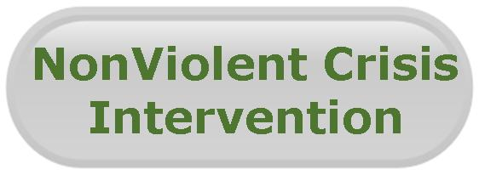
Target Audience
Special Education Teachers
Regular Education Teachers
Paraprofessionals
Special Education Directors
Other Interested Education Professionals

Early Bird Fee (before November 30, 2012)
$100 per participant + additional $13.75 for CPI Book (each participant is required to purchase the book)
(Early Bird Total: $113.75 per participant

Registration Fee (after November 30, 2012)
$150 per participant + additional $13.75 for CPI Book (each participant is required to purchase the book).
Regular Registration Total: $163.75 per participant

Registration fee includes materials, break and lunch

Deadline for Registration
December 11, 2012
(Registrations canceled after registration deadline will not be refunded)

To register go to: www.myquickreg.com

